Name: Hovan Hodges
Course: CST-305
Assignment Name: Project 2 - Runge-Kutta-Fehlberg (RKF) for ODE
Date: 5/17/2026

Responsibilities and completed tasks by each team member
I completed all tasks as I worked on this by myself.
Specific problem solved
Within the assignment description it mentions having an ODE assigned to us to solve, unfortunately, I am not sure if that was provided to us. To make up for this, I will just assign my own ODE to me for this project, I will be using the ODE presented in lab question 3, $\frac{dy}{dx}=-\frac{\frac{3}{x}+y}{3xy}$.
The mathematical approach for solving it
Because the ODE being solved was already solved within lab question 3, I will use those same equations to show my solution.
With x₀ = 1, y₀ = 1, h = 0.1, below is one fully calculated step for $\frac{dy}{dx}=-\frac{\frac{3}{x}+y}{3xy}$ using Fourth-Order Runge-Kutta method.
interim values:
$$k_{1}=f(1, 1)=-\frac{\frac{3}{1}+1}{3(1)(1)}=-\frac{4}{3}$$
$$k_{2}=f(1+\frac{0.1}{2}, 1+(\frac{0.1}{2})(-\frac{4}{3}))=f(1.05, \frac{14}{15})=-\frac{\frac{3}{1.05}+\frac{14}{15}}{3(1.05)(\frac{14}{15})}=-\frac{3980}{3087}$$
$$k_{3}=f(1+\frac{0.1}{2}, 1+(\frac{0.1}{2})(-\frac{3980}{3087}))=f(1.05, \frac{2888}{3087})=-\frac{\frac{3}{1.05}+\frac{2888}{3087}}{3(1.05)(\frac{2888}{3087})}=-\frac{29270}{22743}$$
$$k_{4}=f(1+0.1, 1+(0.1)(-\frac{29270}{22743}))=f(1.1, \frac{19816}{22743})=-\frac{\frac{3}{1.1}+\frac{19816}{22743}}{3(1.1)(\frac{19816}{22743})}=-\frac{2250665}{1798302}$$Calculation for y₁:
$$y_{1}=1+\frac{0.1}{6}\left(-\frac{4}{3}-2\frac{3980}{3087}-2\frac{29270}{22743}-\frac{2250665}{1798302}\right) \\ y_{1}=1+\frac{0.1}{6}\left(-\frac{5168698887749}{668013445638}\right) \\ y_{1}=1-\frac{5168698887749}{40080806738280} \\ y_{1}=\frac{34912107850531}{40080806738280} \\ y_{1}≈0.871043042583958$$
The approach for implementation in code
The implementation for solving the ODE utilizes Python's SciPy library, specifically the solve_ivp function. The mathematical system is defined as a standalone Python function where the dependent variable is handled as an array to accommodate the solver's design. Performance metrics are tracked by wrapping the solver execution with the time.perf_counter() function to measure computation time, while the total number of computational steps and function evaluations are extracted directly from the solver's output objects (sol.t and sol.nfev). Finally, this design allows for testing of problem variations by accepting different parameters for initial conditions and error tolerances, enabling an easy analysis of the tradeoff between computational precision and execution time.

Screenshots depicting key phases in the program execution
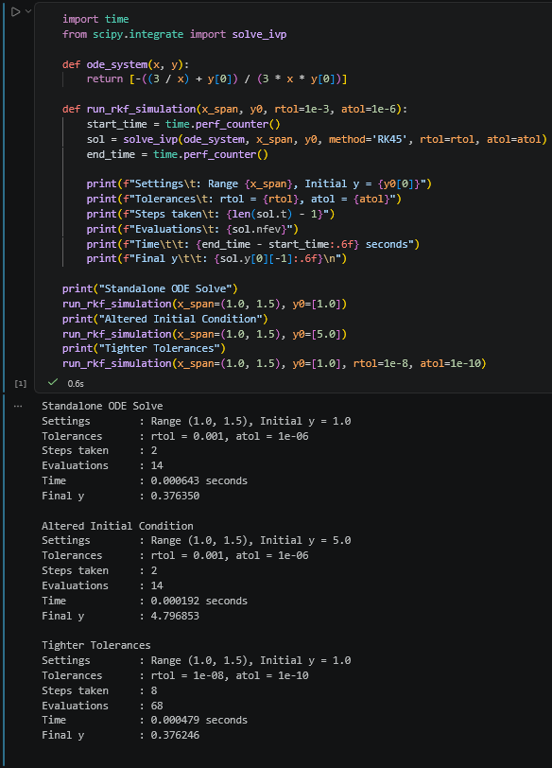
References for theory and code sources
- Google’s Gemini
- Introduction — Runge-Kutta Methods
- Runge-Kutta 4th Order Method to Solve Differential Equation - GeeksforGeeks
- Instructor Kiju Kim’s presentation slides
README document written in Markdown, detailing how to install and run the program
The README.md document is posted within the Github and was uploaded alongside this PDF document inside Halo Learn.

